Style Guidelines for Final Year Project ReportsUrdu Machine Reading Comprehension
Final Year Project



Primary Advisor: Sir Ali Faheem
Secondary Advisor: Akheem Yousaf

Presented by:
22-10391 Salman Anwar
22-10582 Zarek Asif
22-10457 Eraj Khurshid

Department of Computer Science

Forman Christian College (A Chartered University)
Urdu Machine Reading Comprehension

By
Salman Anwar
Zarek Asif
Eraj Khurshid

Project submitted to

Department of Computer Science,

Forman Christian College (A Chartered University),

Lahore, Pakistan.

in partial fulfillment of the requirements for the degree of

BACHELOR OF SCIENCE
IN
COMPUTER SCIENCE (Honors)
Primary Project Advisor |  | Secondary Project Advisor

Senior Project Management Committee Representative

Abstract

Machine Reading Comprehension (MRC) is a challenging task in natural language processing (NLP). It creates systems that can answer questions according to a specific context. Recently, machine reading comprehension has gained progress with different models achieving outstanding result on variety of multilingual datasets. Nevertheless, none of these models adapted the Urdu Language. Our work explores the Urdu language question answering dataset which is made up of by translating SQuAD dataset. The Stanford Question Answering Dataset (SQuAD) is a reading comprehension dataset consisting of 100,000 questions posed by crowdworkers on a collection of encyclopedia report. It is the compilation of the Wikipedia articles with human-annotated question and answer. The wide utilization of SQuAD has brought about the development of other related datasets. We translate SQuAD dataset into Urdu Language by using Google Cloud Platform’s translation API. In this research we are applying rule-based techniques which includes Sliding window technique, cosine similarity, semantic embedding and deep learning techniques which include XLM-RoBERTa and mT5 on this translated dataset. We are applying these techniques to get the maximum accuracy of the answer and we find out that transformers model gives more accurate answers. Furthermore, we evaluate these models with F1 Score, ROUGE-1 and Exact Match. Although, we have discovered the following results of these models on the above-mentioned evaluation: Cosine-similarity gives 42% similarity, sliding window gives 1.1% similarity in Slide-3 and 4.4% similarity in Slide-5; Semantic Embedding gives 40% similarity and lastly XLM-RoBERTa gives 66% similarity and mT5 gives 72 % similarity respectively.

Acknowledgement
As a matter of first importance, we express gratitude toward God Almighty. Our teachers have been our solidarity all through this task. We are exceptionally grateful to our parents and instructors for their help. We uncommonly give our appreciation towards our primary advisor Sir Ali Faheem and our secondary advisor Sir Akheem Yousaf who has helped us all through the method for achieving the objective by driving us from the issues and advantages and disadvantages of the framework. This project is made possible in view of our parent’s prayers, our teacher’s support. Finally, we need to thank ourselves for the help and participation we have gotten from one another.

List of Figures
Figure 1: Machine Reading Comprehension System ....................................................................11

Figure 2: Use Case Diagram..........................................................................................................19

Figure3: System Design Diagram..................................................................................................23

Figure4: Class Diagram ................................................................................................................24

Figure 5: Sequence Diagram .........................................................................................................25

Figure 6: Data FlowDiagram.........................................................................................................26

Figure 7: System Architecture Diagram........................................................................................27

Figure 8: SQuAD Dataset..............................................................................................................31

Figure 9: Urdu Dataset..................................................................................................................32

Figure 10: Filtered Urdu Dataset..................................................................................................33

Figure 11: Workflow Diagram......................................................................................................36

Figure 12: Screen 1.......................................................................................................................37

Figure 13: Screen 2.......................................................................................................................38

List of Tables

Table 1: Add Text …………………………………………………………………………….17

Table 2: Add Question ………………………………………………………………………...18

Table 3: Get Answer …………………………………………………………………….…….18

Table 4: Model’s Results………………………………………………………………………29

Table 5: Model’s Number of answers in predicted text.……………………………………….30

Table 6: Statistics of training and development files of Urdu dataset ………………………...31

Table 7: TC-1 ………………………………………………………………………………….40

Table 8: TC-2 ………………………………………………………………………………….41

Table 9: TC-3 ………………………………………………………………………………….41

Table 10: Test summary of all results …………………………………………………………42

Table of contents
ABSTRACt 3
ACKNOWLEDGEMENT 4
LIST OF FIGURES ……………………………………………………………………………………. 5
LIST OF TABLES ................................................................................................................................... 6
CHAPTER 1. INTRODUCTION............................................................................................................. 7
1.1 INTRODUCTION.............................................................................................................................. 7
1.2 OBJECTIVES ........................................................................................................................... 12
1.3 PROBLEM STATEMENT....................................................................................................... 12
1.4 SCOPE ..................................................................................................................................... 13
CHAPTER 2. REQUIREMENTS ANALYSIS................................................................................... 14
2.1 LITERATURE REVIEW...................................................................................................................... 14
2.2 USER CLASSES AND CHARACTERISTICS ..................................................................... 16
2.3 DESIGN AND IMPLEMENTATION CONSTRAINTS …...................................................... 16
2.4 ASSUMPTIONS AND DEPENDENCIES..................................................................................... 16
2.5 FUNCTIONAL REQUIREMENTS .............................................................................................. 17
2.6 USE CASE DIAGRAM................................................................................................................... 19
2.7 NONFUNCTIONAL REQUIREMENTS ...................................................................................... 20
2.8 OTHER REQUIREMENTS............................................................................................................... 22
CHAPTER 3. SYSTEM DESIGN ................................................................................................ 23
3.1 APPLICATION AND DATA ARCHITECTURE ................................................................... 23
3.2 COMPONENT INTERACTIONS AND COLLABORATIONS............................................... 25
3.3 SYSTEM ARCHITECTURE............................................................................................................... 27
3.4 ARCHITECTURE EVALUATION .............................................................................................. 33
3.5 COMPONENT-EXTERNAL ENTITIES INTERFACE ............................................................ 35
3.6 SCREENSHOTS/PROTOTYPE ......................................................................................................... 36
3.7 OTHER DESIGN DETAILS ...................................................................................................... 39
CHAPTER 4. TEST SPECIFICATION AND RESULTS ..................................... 39
4.1 TEST CASE SPECIFICATION ................................................................................................ 39
4.2 SUMMARY OF TEST RESULTS ......................................................................................... 41
CHAPTER 5. CONCLUSION AND FUTURE WORK .................................................................... 41
5.1 PROJECT SUMMARY ................................................................................................................... 41
5.2 PROBLEMS FACED AND LESSONS LEARNED.................................................................. 42
5.3 FUTURE WORK .............................................................................................................................. 43
REFERENCES ..................................................................................................................... 45
APPENDIX A GLOSSARY ....................................................................................................... 48
APPENDIX B DEPLOYMENT/INSTALLATION GUIDE ............................................... 48
APPENDIX C USER MANUAL ........................................................................................ 48
APPENDIX D STUDENT INFORMATION SHEET ................................................................... 49
APPENDIX E PLAGIARISM FREE CERTIFICATE ....................................................... 50
APPENDIX F PLAGIARISM REPORT ................................................................................................................. 50

Revision History

Name | Date | Reason For Changes | Version
Eraj Khurshid | 7-02-22 | Many issues like; formatting, references, abstract, introduction and some other sections. | 1.0
Salman Anwar | 17-05-22 | Citations and some changes in content of different sections | 1.1
Zarek Asif | 31-05-22 | Corrections, Additional Information | 1.2

Introduction

Introduction
Reading comprehension and question answering are still important and challenging task for machines, which consumes a huge amount of training resources. One of the main problems behind the delayed development of language-specific Question Answering systems is low-resource Asian languages, especially for Urdu language, is the unavailability of datasets. Some dataset development strategies for low-resource languages use English data to execute NLP tasks.
We propose Urdu Question Answering Dataset, a large-scale question-answering dataset designed for Urdu MRC, in response to rising demand and a shortage of standard datasets in Urdu. We use 40,000 Urdu QA by translating English SQuAD Dataset. At first, we have 86,000 lines dataset but after cleaning data in a way that the answers which exists in the context, we consider that lines and we remove the irrelevant lines which does not contain the answer so after cleaning data we are applying different AI techniques. This report consists of following techniques: rule-based techniques which includes Sliding window, cosine similarity, semantic embedding and deep leaning technique which include XLM-RoBERTa and mT5 models.
Urdu belongs to the Indo-Aryan language group, and it is 8th widely spoken language in the world with more than 100 million speakers. In Pakistan Urdu is the national language and is broadly spoken in the Indian subcontinent. As a result of rising demand and a lack of basic Urdu datasets, we've created the Urdu Question Answering Dataset by translating the SQuAD dataset into Urdu. It's a large-scale question-answering dataset created for the Urdu MRC. We first find SQuAD dataset from the internet then translate it into Urdu language using Google Cloud Platform. After that by using google JSON keys and csv files functionality, data frames and modules we translate it into Urdu language.
The research examined information on the distribution of answers and questions, as well as the types of questions. Our dataset contributes to multilingual language handling research by making training material available for studying comprehension tasks. As this is the research-based project so we have proposed few research questions:
- Q1: How useful is MRC dataset for Urdu language and can we use automated translated dataset for Urdu MRC?
- Q2: How effective is pre-trained multilingual architectures for Urdu Question Answering?
We analyze at the MT (Machine-Translated SQuAD) resource in Q1. Even with excellent translation, Machine-translation should be sufficient to train an Urdu-QA dataset, such as the SQuAD-trained dataset. However, we face an issue: The position of the answer span is shifted or lost during translation. Because the results of Q1 demonstrate that MT performance is poor, language-specific (Urdu) QA resources are required. In conclusion, we use the SQuAD dataset to construct the Urdu MRC dataset, which contains various sorts of questions.
To address Q2, we used a multi-lingual Transformer-based architecture to fine-tune an Urdu QA system combining limited crowdsourced data from humans and huge materials that have been converted, resulting a Sliding window gives 0.6% F1 Score, 1.8% ROUGE-1 and 0.01% Exact Match in slide 3 and in slide 5 it gives 1.7% F1 Score, 3.4% ROUGE-1 and 0% Exact Match; Cosine similarity gives 5% F1 Score, 8% ROUGE-1and 0% Exact Match; Semantic Embedding gives 6% F1 Score, 8% ROUGE-1 and 0.00175% Exact Match and lastly XLM-RoBERTa gives 36% F1 Score, 41% ROUGE-1 and 30% Exact Match; mT5 gives 73% F1 Score, 73% ROUGE-1 and 64% Exact Match respectively.

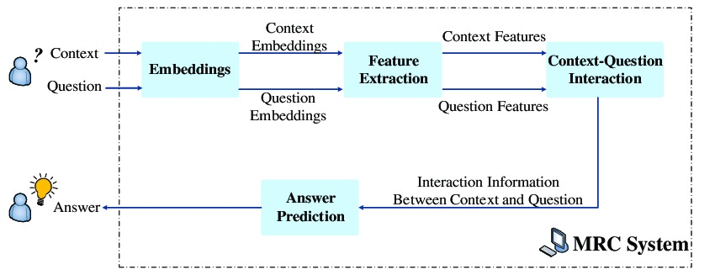

Figure 1: Machine reading comprehension system
Figure 1 shows the MRC system working, how this system works, how it predicts answers from context and questions.

Objectives

The Ultimate target is to develop an accurate predictive model for Urdu Machine Reading Comprehension which will work as a useful tool of question answering for users while solving complex large-scale articles, paragraphs and datasets etc. The major objective of QA frameworks is to answer input questions, but the primary objective of an MRC framework, as its name suggests, is for machines to grasp natural languages. The question is the most important contribution to QA frameworks, whereas the question and the related context in which the question should be used to answer are the most important contributions to MRC frameworks. Our project aims to bring in the usage of several contemporary deep learning model which include XLM-RoBERTa and mT5 models which are a transformer models, it gives more accurate results and rule-based techniques for the best results possible. This system tries to bring in the advanced usage of technology in a field where humans need guidance and help at each step (solving QA etc.,).

Problem Statement
Machine Reading Comprehension (MRC), or the capacity to comprehend unstructured text and afterward answer questions concerning it stays a challenging task for computers. Machine Reading Comprehension (MRC), which allows a machine to respond to questions derived from existing context, is an important approach for evaluating a machine's ability to understand human language. Lately, with the fast advancement of machine learning, particularly deep learning, the examination of machine reading comprehension has gained popularity, and it has arisen in reasonable approach. There is a limited work done in Urdu language. For the Urdu literature major person and other users, it’s difficult to manually solve the large-scale data. So, for the ease of users, we develop a dataset to give the accurate answers in question answering comprehension contexts.
The overall goal of the project is to create an Urdu Machine Reading Comprehension dataset that will answer questions automatically after reading the article with accuracy. Other languages which were used English language datasets for translation and had trouble answering questions correctly after translating them will find our approach useable and efficient. To improve the accuracy of our answers, we use an Urdu dataset with AI models which include baseline techniques and transformer models.

Scope
For the users, this dataset will be act as a question answering platform. It will be meant to increase the user's productivity by giving him or her tools to help automate the answers to the user's comprehension questions, which would otherwise have to be done manually. By maximizing the user's work productivity and production, the dataset will suit all needs while being simple to understand and use. More specifically, this structure is designed to allow a user to enter a specific paragraph or article, then ask questions about that paragraph or article, and the machine would produce and provide the user with the correct answer based on the text.

Requirements Analysis

Literature Review

Machine Reading Comprehension is a cutting-edge technology in Natural Language Processing (NLP). It’s the ability to read and understand unstructured text. It is indeed one of the most major difficulties in Natural Language Processing, because the software must first read and comprehend the context before producing accurate answers to the questions. However, not a single model has been custom-built for the Urdu language. MRC is a significant method for testing machines capacity to comprehend human language. Urdu Machine reading comprehension is a difficult errand and interesting issue in natural language handling.
Following the publishing of SQuAD (Rajpurkar et al., 2016) , a Reading Comprehension (RC) dataset on a wide-scale comprising over 100,000 questions on significant Wikipedia articles, this technique achieved widespread adoption. SQuAD's widespread use more relevant datasets have been created as a result of this. For example, TriviaQA (Joshi et al., 2017) contains 96k trivia game questions and answers found on the internet, as well as documentation confirming the answers. The Natural Questions corpus (Kwiatkowski et al., 2019) is a three-fold larger collection of questions derived from Google search data than SQuAD.
However, some identical MRC datasets for other languages, demanding the creation of multilingual MRC for languages with limited resources. To satisfy this demand, the XSQuAD (Tahsin Mayeesha et al., 2020) dataset was created. It has been translated into eleven languages and which consists of 40 paragraphs and pairing of 1190 question-answer from SQuAD dataset. XSQuaD also includes Arabic and Hindi, but not Urdu. To overcome the shortage of datasets other than English RC, a lot of work has gone in to developing datasets for Reading Comprehension in limited languages in recent years. SberQuAD (Efimov et al., 2020), a dataset for the Russian language that is identical to SQuAD, was developed using the same technique as SQuAD.
Furthermore, (Hardalov et al., 2019) provided a Bulgarian dataset, (Devlin et al., 2019) a Tibetan dataset, and (TiBERT: Tibetan Pre-Trained Language Model | DeepAI, n.d.) created an Arabic Reading Comprehension Dataset (ARCD) to complete the MRC gap in additional languages. With 60k QA pairings, SQuAD-it (Croce et al., 2018), a semi-automated translation of the SQuAD dataset into Italian, is a huge dataset for question answering methods in Italian. (d’Hoffschmidt et al., 2020) provided two versions of FQuAD: French Question Answering Dataset, each with 25k and 60k samples. (Baradaran et al., 2022) HindiRC was introduced with only 127 questions from 24 paragraphs, all of which were manually annotated by humans. Another iteration of the synthetic dataset translated from SQuAD 1.1 for Hindi reading comprehension contains about 18k questions (Gupta et al., 2019). The absence of native language referenced datasets other than English is one of the key reasons why language-specific Question Answering datasets take relatively more time. Hindi and Arabic are two low-resource languages that have made rapid progress in the MRC, with the research community having recently paying attention to them. Despite the fact that Urdu has several features in common with Arabic, Persian, and Hindi, such as the loss of capitalization, combinations of words, comparable grammar, and unrestricted word structure, Urdu is a unique language (Daud et al., 2017), Urdu still faces difficulties in performing basic NLP research.
A team from Karachi, Pakistan, worked on an Urdu MRC Dataset project [UQuAD1.0]. By combining SQuAD with man-made tests from online sources, this study creates the Urdu Question Answering Dataset in a semi-automated manner (UQuAD1.0). UQuAD1.0 is a wide-scale Urdu dataset developed for extracting machine examining appreciation errands, with 49k question and answer sets referred to, as well as section and answer design. 45000 sets of Question Answers were made via machine interpretation of the initial SQuAD1.0 in UQuAD1.0, and roughly 4000 sets were developed through public support. They utilized two kinds of MRC models in this survey: rule-based sliding window baseline and upgraded Transformer-based models. Regardless, they found that transformer model approach works best (Kazi & Khoja, 2021).
The next question is: How will our work be any different from them? To answer this, we will be using SQuAD dataset to make our software working fast and get more precise answers to the questions. And with that we are also implementing multiple rule-based techniques not just one technique which they have use in their dataset. Our techniques include sliding window, semantic embedding and cosine similarity. We will also be working with deep-learning models. We use transformer model XLM-RoBERTa and mT5 models. And, for the answer evaluation we use F1 Score, ROUGE-1 and Exact Match. We will be using addition models and addition datasets to make our software working more precisely and efficient than before.

User Classes and Characteristics
Add Text:
The user will be provided with the space to enter the article/ text or any type of Urdu context.

Add Questions:
The relevant questions from the given text will be entered by the user.

Get Answer:
After evaluation with different models the model will return the most accurate answer.

Design and Implementation Constraints
- While working on this project, we may face different constraint to build up this project.
- The first Constraint will be that we need a huge dataset for the effective learning of the machine.
- After that we translate SQuAD dataset into Urdu language.
- The constraints we faced during translation was that there are many questions taken from 1 paragraph and we have to first write code for this, like it should translate 1 paragraph for all the questions at a time and after that we started translating the dataset.
- After that conversion of the dataset into Urdu language will be a big task:
- Identifying the correct technique(s) to apply (such as Rule Based and Deep Learning based Technique) into the dataset so that the biasness and efficiency of the program will be ensured.

Assumptions and Dependencies
The kind of program being used to develop the datasets will greatly affect the speed of progress. To ensure that software works smooth it must go through a lot of trial to ensure minimal bugs. We are assuming that our text translation from English to Urdu will be accurate by using SQuAD dataset. Furthermore, we are assuming to use different techniques of rule-based model in our dataset so that our dataset will give a precise answer to the question. We are also assuming to use deep learning techniques to find the accuracy of our dataset. If there will be any bug in the techniques or datasets which we are using, then the model will not work properly and will not give the accurate answer.

Functional Requirements
Product features or functions those developers must implement in order for users to complete their duties are known as functional requirements. Functional requirements, in general, describe how a system behaves under specified circumstances. In our project the following use-cases works:

- Add Text
- Add Questions
- Get Answers

Add Text
Identifier |  | Add Text
Purpose |  | Purpose is to provide the Content to the system
Priority |  | High
Pre-conditions |  | User must have opened the system
Post-conditions |  | Text uploaded
Typical Course of Action
S# | Actor Action |  | System Response
1 | First user will Click on Add Text button. |  | Text Here Box will be highlighted.
2 | User will type text or Copy the Content from anywhere. |  | It will highlight the Content.
3 | Then Paste it. |  | Content will be shown in the Content Box.
Table 1: Add text

Add Questions
Identifier |  | Add Questions
Purpose |  | Purpose is to provide the Questions to the system
Priority |  | High
Pre-conditions |  | User must have Entered the Paragraph first.
Post-conditions |  | Questions uploaded Successfully Message
Typical Course of Action
S# | Actor Action |  | System Response
1 | User will Click on Add Questions button. |  | Questions Here Box will be highlighted
2 | User will type text or Copy Questions from anywhere. |  | It will highlight the Content.
3 | Then Paste it. |  | Content will be show in the Content Box.
Table 2: Add Questions

2.5.3 Get Answers
Identifier |  | Get Answers
Purpose |  | Answer the Questions given in the system
Priority |  | High
Pre-conditions |  | User must have uploaded the Questions
Post-conditions |  | System will provide Answers.
Typical Course of Action
S# | Actor Action |  | System Response
1 | User will Click on Get Answers. |  | System will provide Answers.
Table 3: Get Answer

Use Case Diagram

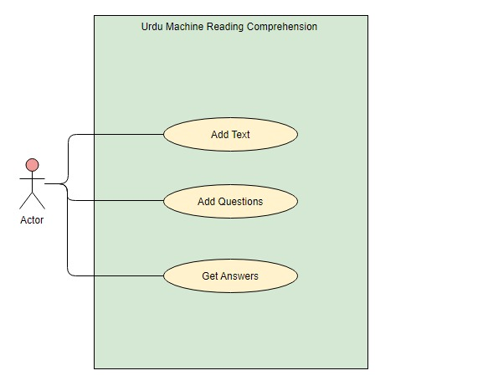
Figure 2: Use Case Diagram

Figure 2 shows the use case diagram of our dataset. How our Urdu Question Answering dataset works.

Nonfunctional Requirements
Nonfunctional requirements define how a system should act and restrict its capabilities. They are explained by the following points, which should be included in the system:

• Accuracy and Precision: To avoid problems, the system's method should be carried out with precision and accuracy. The data that users will see will be reviewed to ensure that it is correct and up to date.

• Adaptability: The system will alter as needed. Any faults should be corrected, and the system should be simple to change. The system will be adaptable to new technology and improvements.

• Security: the system must be secure.

• Usability: the system should be simple to use, clear, and understandable.

• Reliability and Maintenance: The system must be always accessible at any time.

• Speed and responsiveness: Operations should go smoothly.

• System Efficiency and Efficacy: The efficiency and effectiveness of the system will be guaranteed.

• Reliability: The performance of the system will be thoroughly examined.

Non-functional criteria determine the general properties or attributes of the resulting system.

Performance Requirements

Performance is a feature that describes how efficient a system is to various types of user interactions. Both Windows and Mac OS X are supported by the dataset. The dataset requires Windows 7 or higher to work properly. There must be minimum delays and the dataset must be interactive. As a result, there are no immediate delays in the action-response of any dataset.

Safety Requirements
In this dataset, safety criteria aren't particularly important. However, some preventative measures must be taken to avoid any kind of attack.

Security Requirements
The dataset is protected by security requirements from unauthorized access to the system and its data. The system's security requirements are the most important. However, in our instance, the dataset is used as an internet portal for users, which means that anyone can access it without any privacy restrictions, passwords, or check-ins.

Additional Software Quality Attributes

Adaptability: The dataset will be made adaptive to Windows OS and Mac OS.

Availability: The dataset will be made available on an online platform.

Correctness: Dataset will be made free from all the bugs and defects.

Testability: This is an easy to use, user-friendly dataset which is built under basic usage assumptions and hence, can be easily tested.

Maintainability: The maintenance of a dataset is one of the key aspects, in future after the initial part we will be adding more features to this dataset.

User experience: In order to obtain the desired result, the dataset is generally easier to use. Because it is a simple web platform program, users find it simple to use.

Robustness: The only condition that is affecting the working of the dataset is the bad internet connection.

Other Requirements
All requirements have been clearly stated in Final Year report document. No need for additional requirements yet.

System Design

Application and Data Architecture
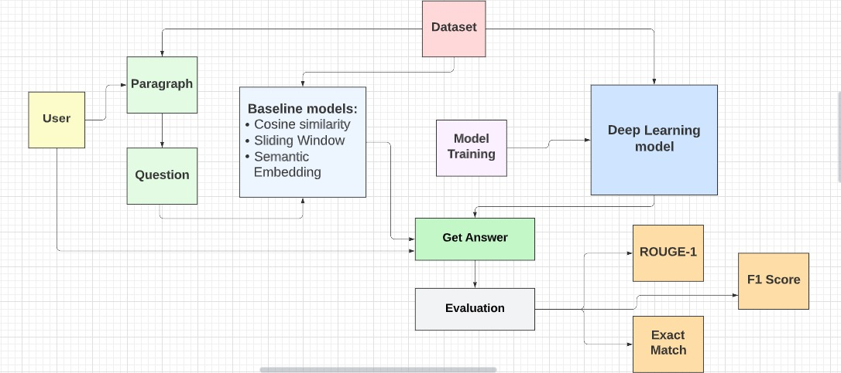

Figure 3: System Design Diagram

Figure 3 shows the system diagram shows how our Urdu machine reading comprehension dataset will work for our users. The application takes the input from the user. It will ask user to paste the text in Urdu. The system then asks the user to enter the question. Once the paragraph and question are given to the system it will then process the rule-based techniques and deep learning techniques on a system. After evaluation with F1 score, ROGUE-1 and Exact Match in that paragraph’s question with the help of these techniques it will provide the most accurate answer.

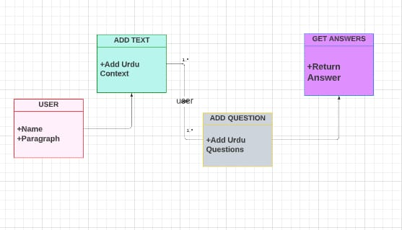

Figure 4: Class Diagram

Figure 4 shows the class diagram represents the Urdu machine Reading Comprehension system and its relationships in the system. It shows the different objects in the system.

Component Interactions and Collaborations

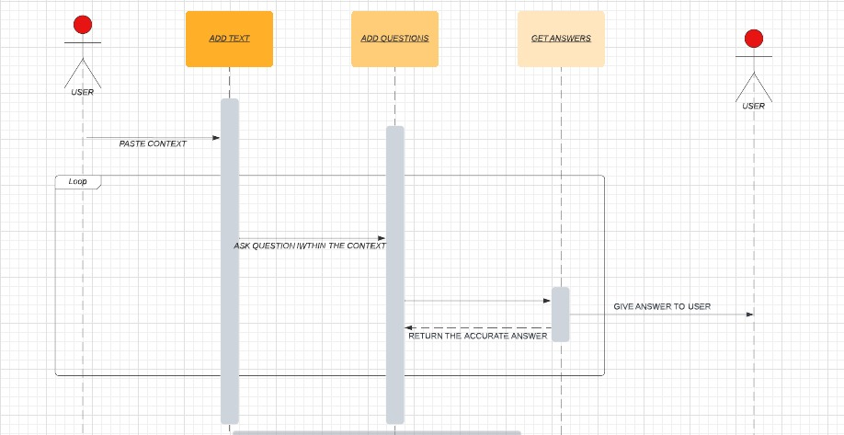

Figure 5: Sequence Diagram

Sequence diagrams in figure 5 represent the interaction between classes or objects according to time. The sequence diagram above provides the type of interaction between the users and the system. The diagram in depth shows the proper flow control of the Urdu Machine Reading Comprehension. It first shows how the user gives the context. Then the user gives the desired question and after the evaluation the system returns the answer to the user.

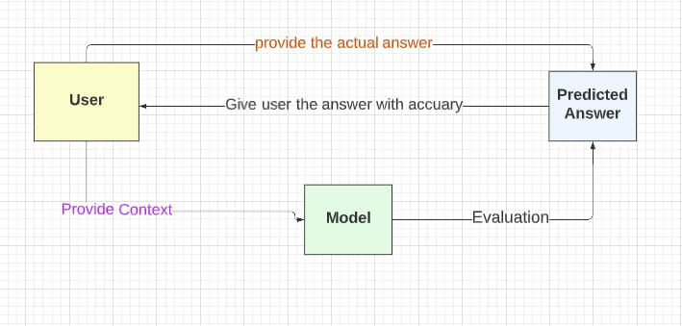

Figure 6: Data Flow Diagram

Figure 6 shows the data flow diagram shows the flow of the Urdu Machine Reading Comprehension. It shows the interaction of user with the dataset.

System Architecture
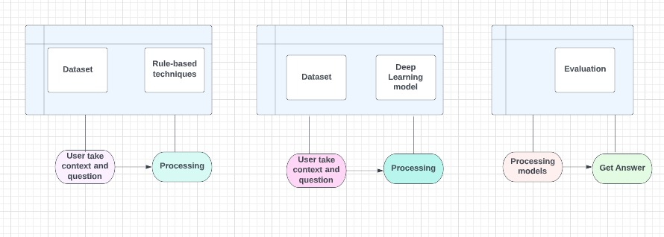

Figure 7: System Architecture
Figure 7 shows the system architecture of our dataset. The dataset will take context and questions and after taking question and context it applies AI techniques and after applying evaluation gives the predicted and most accurate answer.

Methodology:

We compare the performance of three models: a sliding window technique, semantic embedding, and cosine similarity, and a deep learning model (XLM-RoBERTa and mT5 models). Table 6 gives the statistics of our dataset.

- Sliding Windows Technique:

The Sliding Window technique, which was first described in a machine reading comprehension test paper, is a rule-based solution to the answer extraction problem that requires essentially no pre-trained models. The sliding window approach was chosen as the baseline since it is used in the SQuAD dataset and indicates that match frequency or basic word similarity between question and context cannot solve the RC problem. The sliding window technique works as follows for a given (paragraph, question):
1) Tokenize: uses a special Urdu tokenizer from Stanford Stanza Library to turn each paragraph-question-answer tuple into a collection of tokens.
2) Make a list of candidate answers: for the information area, make a list of text ranges. They're dealt with in the same way as application responses are.
3) Predict Answer: The highest-scoring response is the correct one.

- Semantic Embedding:

When you have sentence embeddings registered, you as a rule need to contrast them with one another. Here, we show you how you can process the cosine likeness between embeddings, for instance, to quantify the semantic similarity of two texts. We pass the convert_to_tensor = True boundary to the encode work. This will return a pytorch tensor containing our embeddings. We can then call util.cos_sim(A, B) which processes the cosine likeness between all vectors in A and all vectors in B. It returns in the model a 3x3 network with the separate cosine similarity scores for all potential matches somewhere in the range of embeddings1 and embeddings2.

- Cosine Similarity:

Regardless of paper size, the cosine similarity metric is used to determine how similar documents are. It uses a numerical method to calculate the cosine of a point between two vectors projected in a multi-layered space.

- XLM-RoBERTa:
RoBERTa has a multilingual variant called XLM-RoBERTa. It has been pre-trained on 2.5 TB of filtered CommonCrawl data with 100 languages. It is a self-supervised transformers model that was trained on a big dataset. This implies it was pre-trained on simply the raw texts, with no human classification (which is why it can use very much publicly available data), and then used an automatic method to build inputs and labels from all those texts.
The efficiency of transformer-based models for machine-reading comprehension is investigated in this dataset. Most of the state-of-the-art performance in a range of natural language processing tasks is recorded for this by models constructed on top of the Transformer architecture. We use the transfer learning idea embedded in these models to fine-tune the current pre-trained models for question answering on the Urdu Question Answering dataset in the absence of pre-trained Urdu monolingual models.

- mT5:
mT5 is a multilingual Transformer model that has been pre-trained on a dataset that includes text in 101 languages. It was created to support any Natural Language Processing task (classification, question answering, etc.)

Model Name | F1 Score | ROUGE-1 | Exact Match
Sliding Window | Slide 3: 0.6%  Slide 5: 1.7% | Slide 3: 1.8%  Slide 5: 3.4% | Slide 3: 0.01%  Slide 5: 0%
Cosine similarity | 5% | 8% | 0%
Semantic embedding | 6% | 8% | 0.00175%
XLM-RoBERTa | 36% | 41% | 30%
mT5 | 73% | 73% | 64%
Table 4: Model’s Results

Table 4 shows the Evaluation scores of F1 Score, ROUGE-1 and Exact Match. This gives the values of models: Sliding Window, Cosine similarity, semantic embedding, XLM-RoBERTa and mT5 with accuracy.

Model Name | Number of answers in predicted text
Sliding Window | Slide-3: 1.1%  Slide-5: 4.4%
Cosine similarity | 42%
Semantic embedding | 40%
XLM-RoBERTa | 66%
mT5 | 72%

Table 5: Model’s Number of answers in predicted text
Table 5 gives the Number of answers in predicted text of models: Sliding Window, Cosine similarity, semantic embedding, XLM-RoBERTa and mT5.

Dataset:

We get Urdu Question Answering Dataset by translating the SQuAD dataset through google cloud platform. About our dataset, it contains 40,000 questions, 14,388 unique paragraphs. Table 6 shows the statistics of our Urdu dataset.

 |  | Dataset (All) | Dataset (Train) | Dataset (Test)
Number of questions  Number of unique paragraphs  Avg.number of sentences per- paragraph |  | 40,329  14,388  6.26 | 34,279  12,100  6.19 | 6050  2288  6.28
Tokens | avg. paragraph length  avg. question length  avg. answer length | 159  12  2 | 157  12  2 | 172  12  2
Characters | avg. paragraph length  avg. question length  avg. answer length | 700  53  12 | 690  53  12 | 757  51  14

Table 6: Statistics of training and development files of Urdu dataset

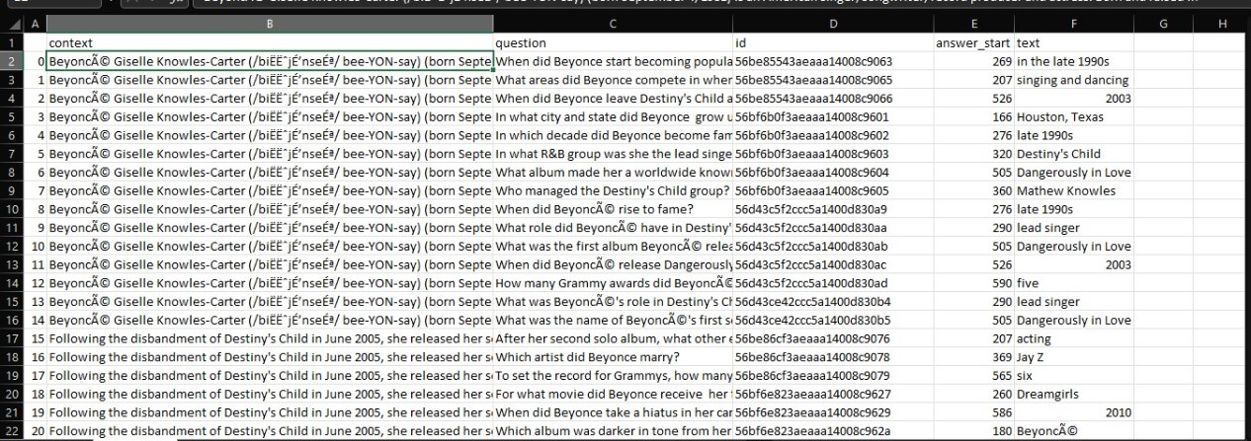

Figure 8: SQuAD Dataset

This is the English SQuAD Dataset as shown in Figure 8 which we used for translation. We convert this dataset into Urdu dataset using Google Cloud Platform.

We created two sets of clarified QA matches, one for training (80%) and one for testing (20%), with no sections or articles crossing over. Table 4 shows the measurements for both parts. The training portion was also divided into two parts: 80 percent for real instruction and 20% for approval.

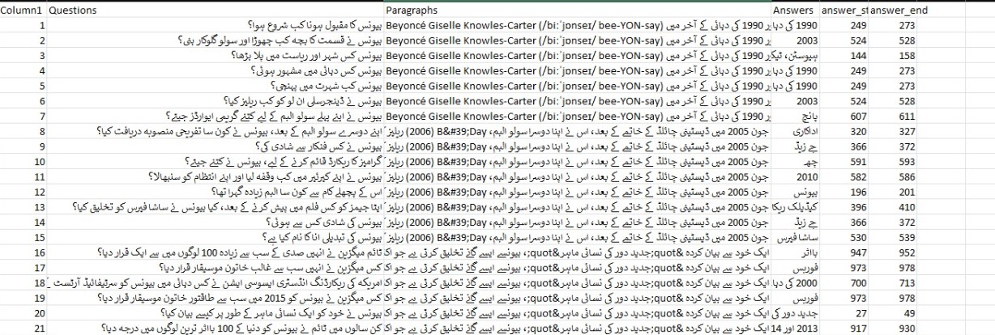

Figure 9: Urdu Dataset

This is the translated raw Urdu dataset as shown in Figure 9. We translate it by using JSON file from the script, doing some coding but this raw data does not give the accurate answer for instance cosine similarity gives 27% accuracy. After that we modify this dataset to get the desired accuracy which we need and for that during translation some answers are not present in the paragraph because of the synonyms and to remove this hinderance we run a script on the whole dataset and make a function and what it will do the questions which are appearing in the dataset will stay in the dataset otherwise it will remove those rows. And after all this process we get a filtered dataset.

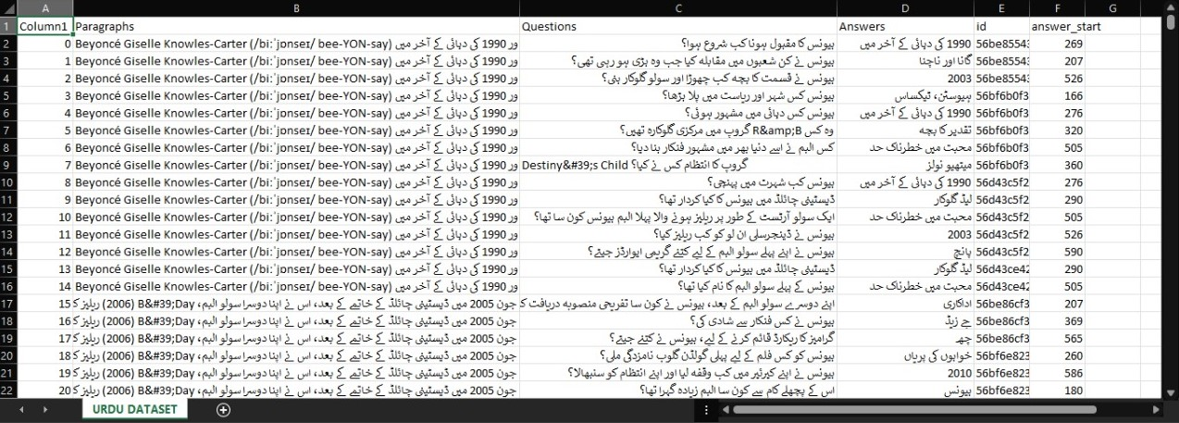

Figure 10: Filtered Urdu dataset

The filtered dataset has 40,000 question and 14,388 unique paragraphs. And this is the final and filtered Urdu Question Answering Dataset as shown in Figure 10.

- Data pre-processing:
While rule-based models and deep learning models such as XLMRoBERTa and mT5 are different models. As a result, the common foundation of all models is described in the following:
We start by preprocessing the entire dataset to remove any noise or inaccuracy that may have been introduced during data collection. We discard cases that demonstrate one or more of the following characteristics:
• There is no answer span in the text.
• Index of wrong responses (text in answer differs from the text in the paragraph).

Architecture Evaluation
To make this dataset more difficult, we don't allow MRC models to make use of simple approaches based on basic word matching. Furthermore, rather of focusing solely on keywords, we aim to create questions that can be answered by reading the entire text. Not every question is equally challenging. Most questions are simple to answer, whereas others will need a lot of thought. We use transformer models as well for accuracy purpose. The SBERT embedding gives more accurate result than other embeddings for instance word matching, because the dataset is larger in size, and this only works on one feature. We choose XLM-RoBERTa and mT5 models; it is a transformer model with high accuracy and precision and give more accurate result than any other model. Table 5 gives each Model Number of answers in predicted text.
Urdu Machine Reading Comprehension was tested for its accuracy and the model performance was remarkable as the trend followed by predicted values were closest to the actual values. We perform baseline approach as a sliding window, semantic embedding, cosine similarity and deep learning techniques. For accuracy measure, we used F1 Score, Exact Match and ROUGE-1.
In many ways, the MRC work is similar to a human reading comprehension task in a way of complexity. In conclusion, the MRC model has been evaluated might follow a similar pattern: The dataset is evaluated by comparing how well it replies to paragraph questions. its responses to the correct ones. This responds to Q3 about the dataset ability to learn RC. So, we can compare the dataset output to the correct answer and give it a 1 if it's correct and a 0 if it's incorrect. This measurement is referred to as Exact Match. On the contrary this will classify slightly right responses as incorrect ones. Regardless of whether the model's result is enormously close to the right response, the specific match score will in any case be zero assuming the right response is "لاہور روشنیوں کا شہر ہے" and the model result is "لاہور روشنیوں " the specific match score will in any case be 0.

F1 score:
A standard extraction metric for evaluating MRC systems is the harmonic mean of precision and recall. As a bag-of-tokens, it considers the output of the system and the ground-truth response (words).
The F1 score is calculated as follows:

𝐹1 = 2 × 𝑝𝑟𝑒𝑐𝑖𝑠𝑖𝑜𝑛×𝑟𝑒𝑐𝑎𝑙𝑙
𝑝𝑟𝑒𝑐𝑖𝑠𝑖𝑜𝑛+𝑟𝑒𝑐𝑎𝑙𝑙

Exact Match:
This is the proportion of accurate answers that matches with the right answers completely. If a dataset contains numerous answers to a question, an exact match is defined as a point that looks exactly like one of the responses.

ROUGE-1:
Then we look at evaluation metrics to see how close model-generated outlines are to perfectly define annotated summaries. In the research community, the ROUGE-1 score has developed as the standard assessment measure for abandoned projects. ROUGE represents Recall-Oriented Understudy for Gisting Evaluation. Despite the fact that ROUGE's name implies that it is ‘recalled-oriented,' it essentially considers both Recall and Precision when comparing applicant (model-created or predicted) and reference (golden-annotated or target) summaries. In our system, we employ ROUGE-1. It has a Precision and Recall measures how comparable reference and candidate summaries are in terms of uni-grams. When we say uni-grams, we simply mean that each comparison token is a single word.

Component-External Entities Interface
The most important aspect of Urdu Machine Reading Comprehension dataset is the AI models that we used. For this purpose, we used rule-based and deep leaning technique in our project. These models were implemented by using NLTK, Spacy, sentence transformer (used in semantic embedding), Ur model library, pytorch, pandas library, these machine learning libraries used to train, test and make prediction on our dataset. The dataset uses Google APIs (it is a programming interface application established by Google that enables communication with Google Services and connect them to other services) to convert an English dataset to an Urdu dataset.

Screenshots/Prototype

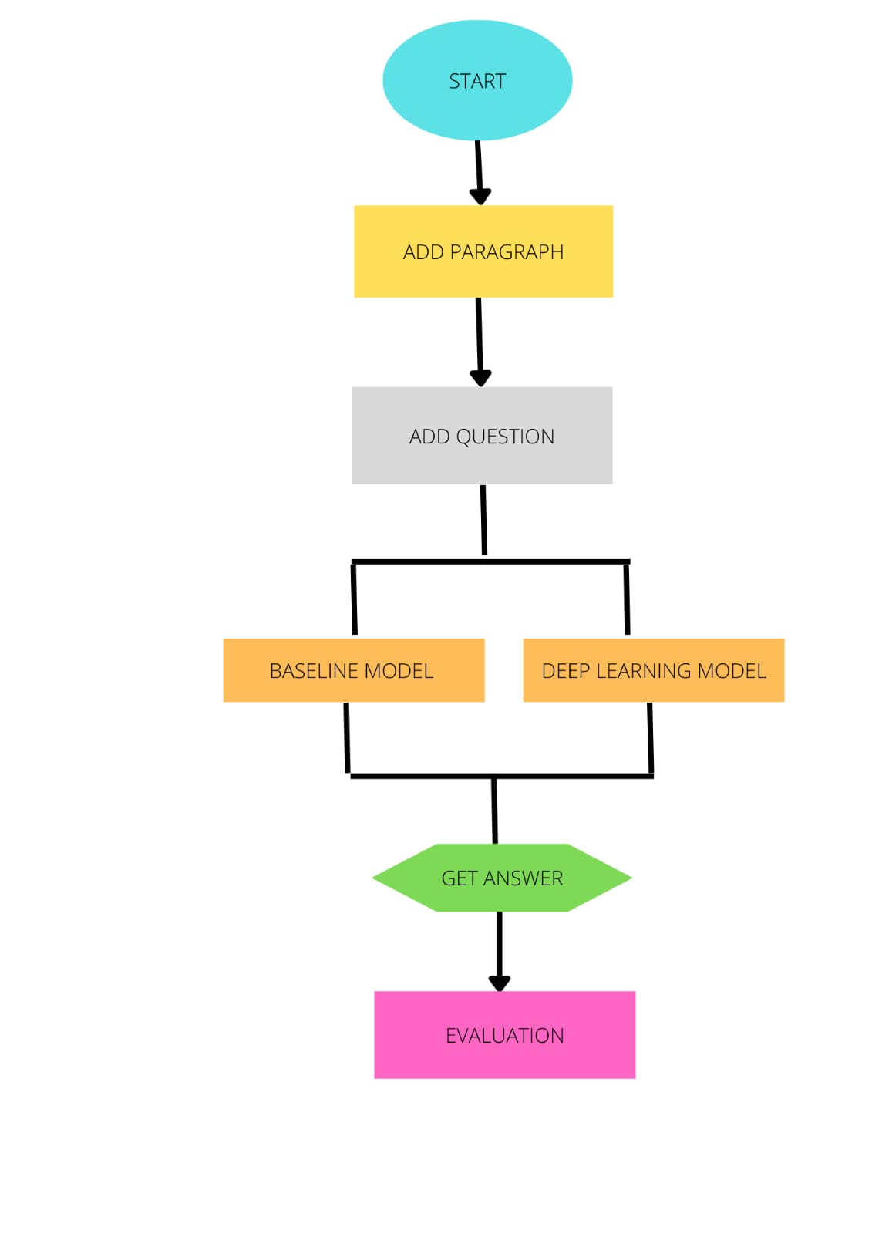
Workflow

Figure 11: Workflow Diagram

Figure 11 shows the workflow of our Urdu Question Answering Dataset.

Screens
- Cosine Similarity:
Question:

جولائی 2002 میں، بیونس نے کامیڈی فلم، آسٹن پاورز ان گولڈ میمبر میں مائیک مائرز کے ساتھ فوکسی کلیوپیٹرا کا کردار ادا کرتے ہوئے اپنا اداکاری کا کیریئر جاری رکھا، جس نے اپنے پہلے ویک اینڈ کو امریکی باکس آفس پر گزارا اور $73 ملین کمائے۔ بیونس نے اپنے ساؤنڈ ٹریک البم سے لیڈ سنگل کے طور پر &quot;ورک اٹ آؤٹ&quot; جاری کیا جس نے یوکے، ناروے اور بیلجیئم میں ٹاپ ٹین میں داخلہ لیا۔ 2003 میں، بیونس نے کیوبا گوڈنگ، جونیئر کے مقابل، میوزیکل کامیڈی دی فائٹنگ ٹیمپٹیشنز میں للی کے طور پر کام کیا، ایک اکیلی ماں جس سے گڈنگ کا کردار پیار کرتا ہے۔ فلم کو ناقدین کی طرف سے ملے جلے جائزے ملے لیکن امریکی بیونسے نے فلم کے ساؤنڈ ٹریک البم سے لیڈ سنگل کے طور پر &quot;فائٹنگ ٹیمپٹیشن&quot; ریلیز کی جس میں مسی ایلیٹ، ایم سی لائٹ اور فری کے ساتھ $30 ملین کمائے جو فلم کی تشہیر کے لیے بھی استعمال کیے گئے۔ ساؤنڈ ٹریک میں بیونس کی ایک اور شراکت، &quot;سمر ٹائم&quot; نے امریکی چارٹ پر بہتر کارکردگی کا مظاہرہ کیا۔

Questions: گولڈ میمبر میں آسٹن پاورز میں بیونس کے کردار کو کیا کہا جاتا تھا؟

Predicted answer is: جولائی 2002 میں، بیونس نے کامیڈی فلم، آسٹن پاورز ان گولڈ میمبر میں مائیک مائرز کے ساتھ فوکسی کلیوپیٹرا کا کردار ادا کرتے ہوئے اپنا اداکاری کا کیریئر جاری رکھا

True Answer: فاکسی کلیوپیٹرا

Recall | F1 | ROUGE-1 | Exact Match
2/2 = 1 | 0.1818 | 0.1818 | 0

Figure 12: Screen 1
Figure 12 shows how our dataset gives the predicted answer using a technique cosine similarity with the evaluation using F1 score, exact match and ROUGE-1.

- mT5 model:

Paragraph:
ایک خود سے بیان کردہ &quot;جدید دور کی نسائی ماہر&quot;، بیونسے ایسے گانے تخلیق کرتی ہے جو اکثر محبت، رشتوں اور یک زوجگی کے ساتھ ساتھ خواتین کی جنسیت اور بااختیار بنانے کے موضوعات سے بھی متصف ہوتے ہیں۔ اسٹیج پر، اس کی متحرک، انتہائی کوریوگرافڈ پرفارمنس نے ناقدین کو عصری مقبول موسیقی کی بہترین تفریح کاروں میں سے ایک قرار دیا۔ 19 سال پر محیط اپنے کیریئر کے دوران، اس نے ایک سولو آرٹسٹ کے طور پر 118 ملین سے زیادہ ریکارڈز اور ڈیسٹینی چائلڈ کے ساتھ مزید 60 ملین ریکارڈز فروخت کیے ہیں، جس سے وہ اب تک کے سب سے زیادہ فروخت ہونے والے میوزک فنکاروں میں سے ایک ہیں۔ وہ 20 گریمی ایوارڈز جیت چکی ہیں اور ایوارڈ کی تاریخ میں سب سے زیادہ نامزد ہونے والی خاتون ہیں۔

Question: بیونس نے کتنے گریمی ایوارڈز جیتے ہیں؟

Predicted answer is 20

True Answer: 20
Recall | F1 | ROUGE-1 | Exact Match
100% | 100% | 100% | 100%

Figure 13: Screen 2
Figure 13 shows how our dataset gives the predicted answer using a technique mT5 model with the evaluation using F1 score, exact match and ROUGE-1.

Other Design Details
The dataset can be run on any python interpreter. You can use Jupyter notebook, Anaconda etc. This design details includes the dependencies of the packages installed able to run the project. NumPy, NLTK, Spacy, sentence transformer (used in semantic embedding), pytorch, pandas library among other libraries and frameworks were used.

Test Specification and Results

Test Case Specification
Identifier | TC-1
Related requirements(s) | Add Text
Short description | This function requires Urdu paragraph
Pre-condition(s) | Taking paragraph from the dataset
Input data | Urdu paragraph
Detailed steps | Rule-based Technique, deep learning model predicting the Answers
Expected result(s) | Receive/Save paragraph
Post-condition(s) | System Requires Question
Actual result(s) | Receive/Save paragraph
Test Case Result | Pass
Table 7: TC-1

Identifier | TC-2
Related requirements(s) | Add Question
Short description | This function requires Urdu question
Pre-condition(s) | Taking question from the paragraph
Input data | Urdu question
Detailed steps | Rule-based Technique, deep learning model predicting the Answers
Expected result(s) | Accurate Answer
Post-condition(s) | None
Actual result(s) | Accurate Answer
Test Case Result | Pass
Table 8: TC-2

Identifier | TC-3
Related requirements(s) | Get Answer
Short description | Our models predicted the most accurate answer
Pre-condition(s) | Taking paragraph and question from the dataset
Input data | Urdu paragraph and question
Detailed steps | Rule-based Technique, deep learning model predicting the Answers
Expected result(s) | Accurate Answer
Post-condition(s) | None
Actual result(s) | Accurate Answer
Test Case Result | Pass
Table 9: TC-3

Summary of Test Results

Module Name | Test cases run | Number of defects found | Number of defects corrected so far | Number of defects still need to be corrected
Module 1 (Add Text) | TC1 | 0 | 0 | 0
Module 2  (Add Question) | TC2 | 0 | 0 | 0
Module 3  (Get Answer) | TC3 | 0 | 0 | 0
Complete System | TC1, TC2, TC3 | 0 | 0 | 0
Table 10: Summary of All Test Result

Conclusion and Future Work

Project summary
This project has provided a safe and secure solution for its user. Urdu Machine reading comprehension is a challenging task and interesting issue in natural language processing. It’s the ability to read and understand unstructured text. It is indeed one of the most major difficulties in Natural Language Processing because the software must first read and comprehend the context before producing accurate answers to the questions. However, not a single model has been custom-built for the Urdu language. It becomes a need in keeping with the current cutting-edge technology especially for the Urdu literature users. This dataset provides a platform so that the users get the desired and accurate answers. Making it very useful and productive in most environments. We conducted our research to study the techniques on Urdu Machine Reading Comprehension dataset. We first make an Urdu dataset by translating the SQuAD dataset. After translation we apply different baseline techniques and deep learning techniques. The research was carried out with the help of AI models, to be specific Rule-based and deep learning techniques was used to carry out this research. We use Baseline techniques which include sliding window, cosine similarity and semantic embedding and Roberta. We apply these techniques on our Urdu dataset and evaluate these techniques with the help of F1 score, Exact Match and ROUGE-1 to get the more precise and accurate answer. Our dataset is user friendly, and anybody can use it easily especially it gives benefit to Urdu literature users.

Problems faced and lessons learned
- Several issues arose throughout the completion of this project:
- Firstly, it is a massive undertaking. It was a challenging assignment to learn and put into practise. We have no experience with machine reading comprehension, particularly in the Urdu language and several modules.
- Secondly, there is not a single dataset available on the internet because there is not much work done on this language. No codes or any machine learning, deep learning technique available on the internet.
- Thirdly for the translation purpose we did not find any VISA card but after some days we get cards and use 2 VISA card for translation process and translate the English SQuAD dataset into Urdu dataset.
- Lastly, Training and testing large amount of data on personal computers with limited amount of CPU and GPU processing was a very difficult task. creating a subset of data to be utilized for training and testing of model was proven impossible due to the need to use supervised learning for the model. In addition, creating such training and testing data could not be possible as creating a quality training data set requires time and large amount of effort as it would require manually going through thousands of texts as having
a limited number of training dataset limited the vocabulary of the model.
    - We had many technical problems like working on code and all the errors.

- We discovered a lot of new information, including how to use all of the components, libraries, and frameworks. We learned a crucial lesson: through togetherness, collaboration, and teamwork, we can achieve extraordinary things.

Future work
Machine reading comprehension, which is a popular exam topic in Natural Language Processing, requires to read and respond to questions concerning the document(s). The desired objective of an MRC framework is to have thorough knowledge of context so that you can answer related questions. In this project, we give a brief overview of many features of active MRC studies, including as methods, understand the structure, input/output type, research contributions, and evaluation measures. This work presents the Urdu Dataset, which is derived from the SQuAD Dataset, an open-source Urdu machine reading comprehension (MRC) dataset with a large scope that is meant to deal with actual MRC challenges in the Urdu low-resource language.
We discovered that the dataset cannot handle Abstractive models within this framework. Moreover, the dataset can be extended for the purpose of accuracy, because we translate this dataset using SQuAD dataset and it does not give much accuracy because of the same words as synonyms in the paragraphs and, we found invalid id’s that does not match during translation. Furthermore, we can make a pure Urdu language dataset other than translating other datasets into Urdu language, it will give more accuracy. Further investigation is needed to determine the model's limitations, as well as to foster certain increments that are unique to the Urdu language. Also, if we use more transformers model, we will get the more accurate answer.

References
Trung, L. H. (2019). https://euroasia-science.ru/pdf-arxiv/the-controllability-function-of-polynomial-for-descriptor-systems-23-31/. EurasianUnionScientists, 4(65). https://doi.org/10.31618/esu.2413 9335.2019.4.65.27

CiteSeerX — query based Arabic text summarization 1. (n.d.). Retrieved December 6, 2021, from https://citeseerx.ist.psu.edu/viewdoc/summary?doi=10.1.1.308.4480.

Zhao, M., Yan, S., Liu, B., Zhong, X., Hao, Q., Chen, H., Niu, D., Long, B., & Guo, W. (2020, October 28). QBSUM: A large-scale query-based document summarization dataset from real-world applications. Computer Speech & Language. Retrieved December 6, 2021, from https://www.sciencedirect.com/science/article/abs/pii/S0885230820300991.

Kumar, Y., Kaur, K., & Kaur, S. (2021, February 12). Study of automatic text summarization approaches in different languages. Artificial Intelligence Review. Retrieved December 6, 2021, from https://link.springer.com/article/10.1007/s10462-021-09964-4.

Nawaz, A., Bakhtyar, M., Baber, J., Ullah, I., Noor, W., & Basit, A. (2020, September 25). Extractive text summarization models for Urdu language. Information Processing & Management. Retrieved December 6, 2021, from https://www.sciencedirect.com/science/article/abs/pii/S0306457320308785.

Nguyen, T., Rosenberg, M., Song, X., Gao, J., Tiwary, S., Majumder, R., & Deng, L. (2016, January). MS MARCO: A human generated machine reading comprehension dataset. In CoCo@ NIPS.

Sun, K., Yu, D., Yu, D., & Cardie, C. (2018). Improving machine reading comprehension with general reading strategies. arXiv preprint arXiv:1810.13441.

Baradaran, R., Ghiasi, R., & Amirkhani, H. (2020). A survey on machine reading comprehension systems. Natural Language Engineering, 1-50.

Zhang, Z., Yang, J., & Zhao, H. (2020). Retrospective reader for machine reading comprehension. arXiv preprint arXiv:2001.09694, 1, 1-9.

Liu, S., Zhang, X., Zhang, S., Wang, H., & Zhang, W. (2019). Neural machine reading comprehension: Methods and trends. Applied Sciences, 9(18), 3698.

Zhang, Z., Zhao, H., & Wang, R. (2020). Machine reading comprehension: The role of contextualized language models and beyond. arXiv preprint arXiv:2005.06249.

Guo, S., Guan, Y., Tan, H., Li, R., & Li, X. (2021). Frame-based neural network for machine reading comprehension. Knowledge-Based Systems, 219, 106889.

Ahmed, S. (2021). UQuAD1. 0: Development of an Urdu Question Answering Training Data for Machine Reading Comprehension.

Gupta, V., Joshi, N., & Mathur, I. (2014). Evaluation of English-to-Urdu Machine Translation. In Intelligent Computing, Networking, and Informatics (pp. 351-358). Springer, New Delhi.

P. Rajpurkar, J. Zhang, K. Lopyrev, and P. Liang, “Squad: 100,000+ questions for machine comprehension of text,” arXiv preprint arXiv:1606.05250, 2016.

A.Daud, W. Khan, and D. Che, “Urdu language processing: a survey,” Artificial
Intelligence Review, vol. 47, no. 3, pp. 279– 311, 2017.

M. Joshi, E. Choi, D. S. Weld, and L. Zettlemoyer, “Triviaqa: A large scale distantly
supervised challenge dataset for reading comprehension,” arXiv preprint arXiv:1705.03551,
2017.
T. Kwiatkowski, J. Palomaki, O. Redfield, M. Collins, A. Parikh,
C. Alberti, D. Epstein, I. Polosukhin, J. Devlin, K. Lee et al., “Natural questions: a benchmark
for question answering research,” Transactions of the Association for Computational Linguistics,
vol. 7, pp. 453–466, 2019.

M. Hardalov, I. Koychev, and P. Nakov, "Beyond English-only reading comprehension:
Experiments in zero-shot multi-lingual transfer for Bulgarian," arXiv preprint arXiv:1908.01519,
2019.
Y. Sun, S. Liu, C. Chen, Z. Dan, and X. Zhao, “Construction of high-quality Tibetan dataset
for machine-reading comprehension," in Proceedings of the 20th Chinese National Conference
on Computational Linguistics, 2021, pp. 208–218.
H. Mozannar, K. E. Hajal, E. Maamary, and H. Hajj, “Neural Arabic question answering,”
arXiv preprint arXiv:1906.05394, 2019.

D. Croce, A. Zelenanska, and R. Basili, “Neural learning for question answering in Italian,”
in International Conference of the Italian Association for Artificial Intelligence. Springer, 2018,
pp. 389–402.

M. d’Hoffschmidt, W. Belblidia, T. Brendlé, Q. Heinrich, and M. Vidal, “Fquad: French question answering dataset,” 2020.
K. Anuranjana, V. A. Rao, and R. Mamidi, “Hindirc: A dataset for reading comprehension
in Hindi,” in 0th International Conference on Computational Linguistics and Intelligent Text,
2019.
D. Gupta, A. Ekbal, and P. Bhattacharyya, “A deep neural network framework for English
Hindi question answering,” ACM Transactions on Asian and Low-Resource Language
Information Processing (TALLIP), vol. 19, no. 2, pp. 1–22, 2019.

Glossary

Terminologies | Description
MRC | Machine Reading Comprehension
NLP | Natural Language Processing
AI | Artificial Intelligence
BERT | Bidirectional Encoder Representations from Transformers
Model Training | Learning values for all the weights and the bias from labelled values.

Deployment/Installation Guide
Urdu machine reading comprehension is a dataset that can be accessed through a stable internet connection once it is published online.

User Manual

Following steps should be performed by the user:
- The user will add a context.
- After paste a context, the user will provide the question
- After providing question the dataset starts working and give an accurate answer,
- The user will get an answer.

Student Information Sheet
Roll No | Name | Email Address (FC College) | Frequently Checked Email Address | Personal Cell Phone Number
22-10391 | Salman Anwar | 22-10391@formanite.fccollege.edu.pk | 22-10391@formanite.fccollege.edu.pk | 0323-4409546
22-10457 | Eraj Khurshid | 22-10457@formanite.fccollege.edu.pk | 22-10457@formanite.fccollege.edu.pk | 0324-8400849
22-10582 | Zarek Asif | 22-10582@formanite.fccollege.edu.pk | 22-10582@formanite.fccollege.edu.pk | 0307-4701859

Plagiarism Free Certificate

This is to certify that, I am ________________________ S/D/o _______________________, group leader of FYP under registration no _________________ at Computer Science Department, Forman Christian College (A Chartered University), Lahore. I declare that my Final year project report is checked by my supervisor and the similarity index is ________% that is less than 20%, an acceptable limit by HEC. Report is attached herewith as Appendix F. To the best of my knowledge and belief, the report contains no material previously published or written by another person except where due reference is made in the report itself.
Date: ____________ Name of Group Leader: ________________________ Signature: _____________

Name of Supervisor: _____________________ Co-Supervisor (if any):____________________
Designation: _____________________ Designation: _____________________
Signature: _____________________ Signature: _____________________

Senior Project Management Committee Representative: _____________________
Signature: _____________________

Plagiarism Report

